Public Community Discovery

Users  - Primary  - Community manager  - Secondary | Phase 1
Intended Outcome
- Organizers create their community profile as they want their communities to become visible to outsiders and prospective members.
Links
- Figma
- …
- …
- …
- …

Introduction
One of the community organizers we invited to try Kolavo ended up leaving after registration and saying that he wanted to see communities in it before creating his own. This seems he did not have the motivation of creating his community profile because he did not know what it would look like. Therefore, we want to motivate community organizers to create their community profiles by making community lists visible to the public.

Product Requirement
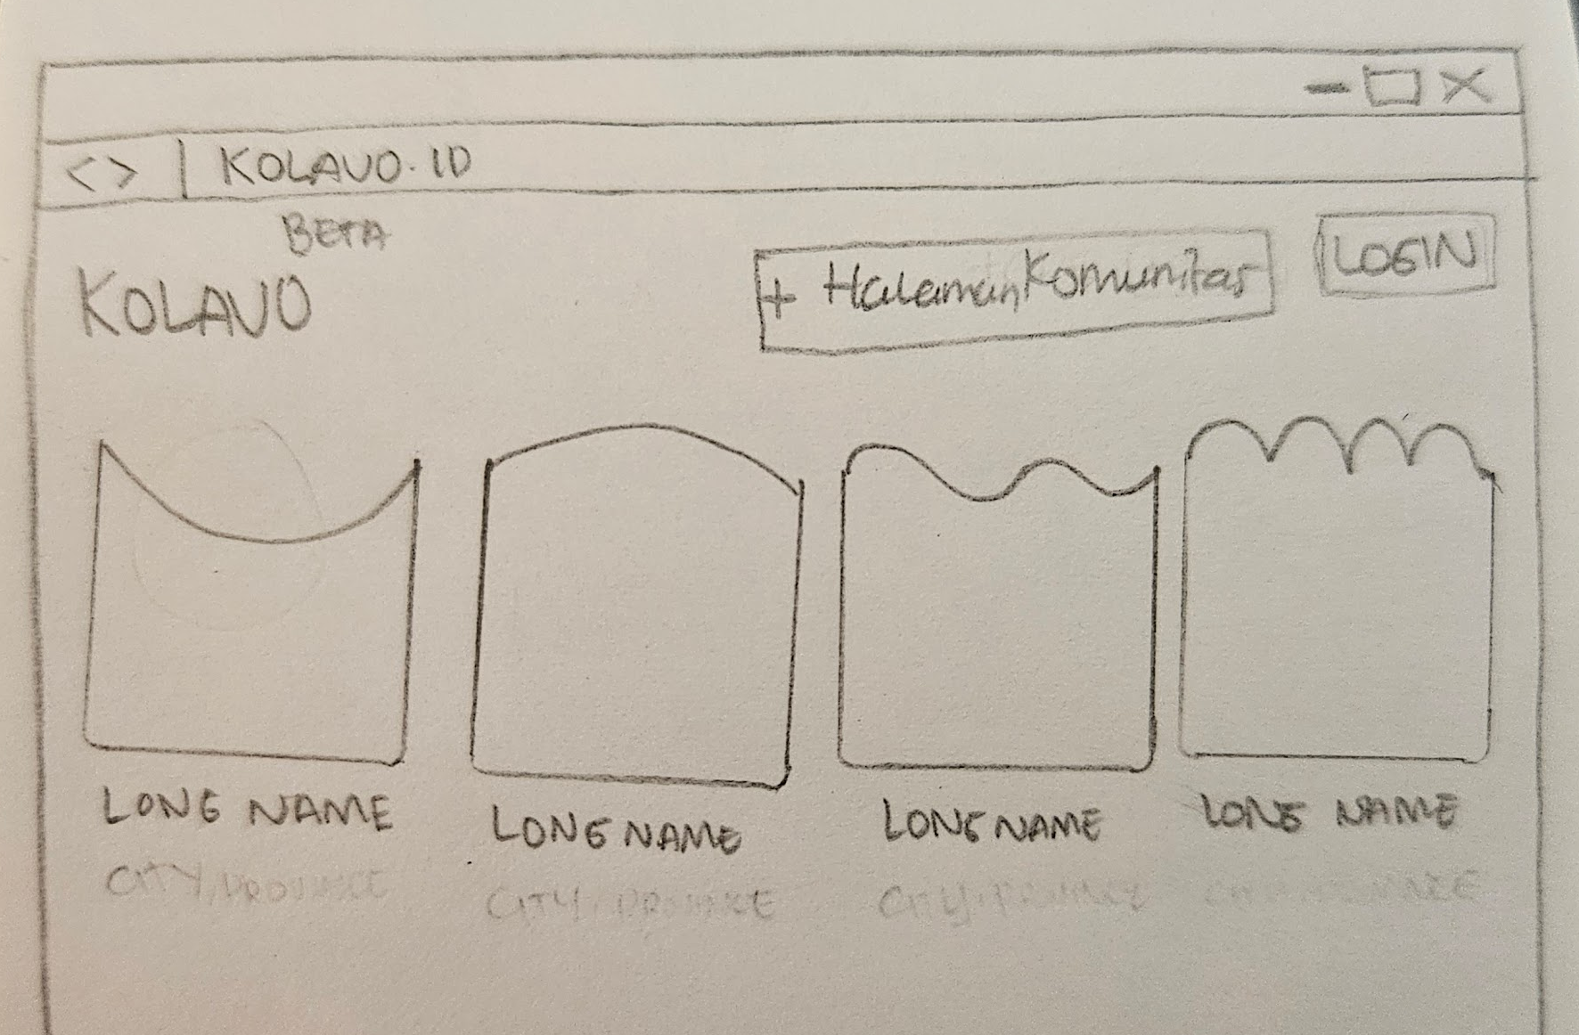
No. | User story | Scope | Acceptance Criteria
1 | As community organizers, I want to see what listed communities look like | Community directory visible to non registered users | - All visitors who access Kolavo.id directed to homepage contains community directory
1 |  | Show fixed first-page display limit in home page | - Each community position should not be fixed. It should be dependent on how much info within each community.
1 |  | Differentiables community identities | Showing:  - Logo  - Long name (5-10 words)
2 | As community organizers, I want to see further information of listed communities | When a community clicked, opens community page | - Community page opened has to be the same with community linked
3 | As community organizers, I want to create my own community profile | Create community button | - Easy to find  - If not logged in, redirect to login process, then to create community form page  - If logged in, direct to create community form page
4 | As community organizers, I want to access it on mobile phone when needed | Mobile responsive | - Looking tidy when accessing using mobile phone  - Have accessible menu
5 | As community organizers, I want to easily know where to login | Login button | - Easy to find  - When clicked, direct to login page/modal

Design Requirement

Kolavo Logo
Design Intent | Show Kolavo brand clearly
Content / Copy | Use Kolavo logo.
Visual Requirement
Interaction Behavior | Static element. No hover or interaction required.
Acceptance Criteria | Kolavo logo is displayed clearly in the header and remains readable on desktop and mobile.

Tambah Halaman Komunitas Button
Design Intent | The primary CTA should be eye-catching, represent Kolavo, and encourage community organizers to create their page.
Content / Copy | + Halaman Komunitas
Visual Requirement
Interaction Behavior
Acceptance Criteria

Homepage Header
Design Intent | The homepage header should feel conversational, inviting, and not too formal.
Content / Copy | Mana Database Anggota Komunitasmu?
Visual Requirement
Interaction Behavior
Acceptance Criteria

Homepage Sub Header
Design Intent | The homepage sub header should encourage visitors to discover communities or create a new one.
Content / Copy | Temukan dan bergabung ke komunitasmu atau buat yang baru. Karena tak kenal, maka tak kolab.
Visual Requirement
Interaction Behavior
Acceptance Criteria

Community Logo
Design Intent | Each community should feel visually distinct through its own logo identity.
Content / Copy | No copy.
Visual Requirement | - No background color and following to unique community logo shape
Interaction Behavior
Acceptance Criteria

Community Long Name
Design Intent | Community names should look consistent by default, while still becoming more distinctive during interaction.
Content / Copy | Use each community’s long name.
Visual Requirement
Interaction Behavior | - On mouse hover, the long name changes to the selected community theme color.
Acceptance Criteria

Community Card
Design Intent | Community cards should feel light and minimal by default, while still showing interactivity on hover.
Content / Copy | - No fixed copy.  - Each card contains a community-specific logo and long name.
Visual Requirement
Interaction Behavior | - On mouse hover, add a very thin transparent Kolavo blue border and a subtle shadow on the right, left, and bottom side of the card.  - Keep layout stable.
Acceptance Criteria

Login Button
Design Intent | The Login button should remain visible and accessible, but visually secondary to the + Halaman Komunitas CTA.
Content / Copy | Login
Visual Requirement
Interaction Behavior
Acceptance Criteria

Bottom Navigation Bar (Mobile)
Design Intent | The homepage should remain easy and comfortable to access on mobile without losing the main actions.
Content / Copy | Showing three menus:  - Community List: Komunitas  - Create community page: Buat  - Account: Akun
Visual Requirement
Interaction Behavior | - Directs to homepage when Komunitas button is clicked  - Directs to Create Community Page Form when Buat button is clicked  - Directs to user account when Akun button is clicked
Acceptance Criteria

Engineering Requirement

Questions

